

MATES Computer Science

**Senior Capstone Project Bi-Weekly Progress Report**

| Project Title | Journal Time! |
| --- | --- |
| Team Members | Shayne Lada, Ava McNabb, Lauren McNaboe |
| Dates Covered by Report | 4/05/24 - 4/19/24 |
| Link to Github | <https://github.com/code-shayne/journal-time-/tree/main> |

# **Summary of Project**

Journal Time! is a web app that allows users to journal and store entries online. The web app would provide prompts or free-journaling options and save all entries to unique user accounts. Users can also track emotions by indicating what they are feeling at the time of journaling. After each entry the user will receive a certain number of points or currency, incentivising journaling. The points can be used to buy accessories within the website such as different prompt packages, website themes, or journaling pets. The journaling pets would be avatars that live on the interface and encourage the user to journal and provide motivational messages. Points could also be used to customize and feed/play with pets. Users can track their journaling progress and view graphs and summaries of their emotions in a separate space on the web app. Email notifications can be scheduled to remind the user to journal or sent if the account hasn’t been used for 2 weeks. This project will encourage journaling, which is a useful practice for mental health and wellbeing. It will also make the process more accessible and fun for the users.

1. Summary of Progress this Period

This sprint we fixed bugs in our code from previous sprints. We updated Javascript functions and code surrounding them to make them work correctly. We also worked on the theme changing feature. Lauren and Shayne both created functions for changing the color scheme of the website when a different theme button is pressed. Going forward we will implement Lauren’s code with maybe a few tweaks.

# **Detailed Progress this Period, separated by Team Member**

Lauren -

* website themes: worked on changing the colors on the entire website and keeping them when you switch to another tab
  + both Shayne and I worked on this
  + annoying since you need to make new css files for each theme (we used variables for the colors so you can change them at the top of the file). With different css files, if you make a change in the main stylesheet, you need to change it in every single other file.

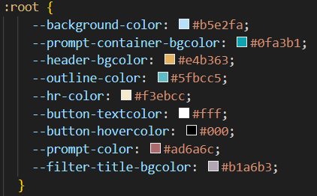

variables for beach theme

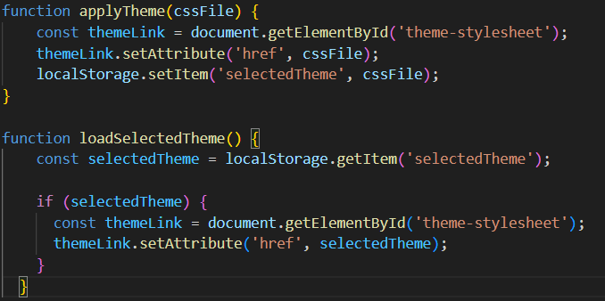

JavaScript functions for changing the theme. applyTheme() takes the css file that the button corresponds to and changes the href at the beginning of the html sheet ↓



loadSelectedTheme() checks the local storage for what theme was previously selected and applies it to the other pages

* login page (i promise i have been working on this, it is just so confusing): I created a separate tab for resetting your password
  + originally, I was going to create a popup that was linked on the login page, but that didn’t work.
  + all of the code is the same with the same Javascript functions, but the display is not displaying

Shayne -

* emotion buttons: I figured out the problems with these buttons and fixed them. Now they function as expected. They don’t stretch out or show the bullet points anymore and I was able to move the section up to be next to the journaling space. (I showed this in my demo)
* store products: I created three different containers for the themes, prompt packages, and pets that scroll using arrows (which took me a while to figure out how to code). When you click on the name of each section it goes to a page of only those types of items. The user can then search, sort, and filter from there to find what they’re looking for. The items are all placeholders.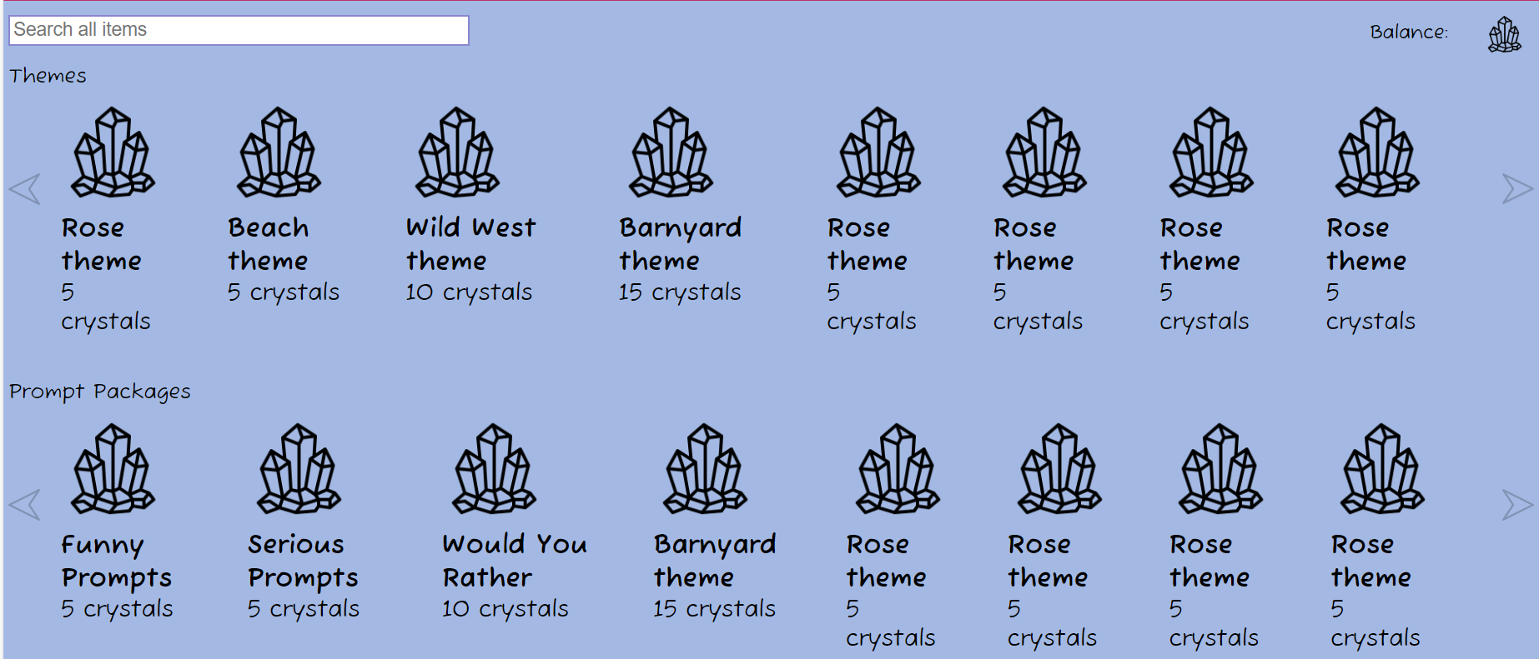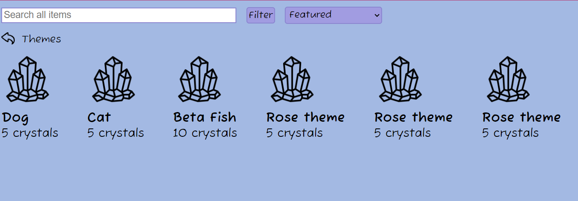
* scroll arrows: I realized the scroll function I was working on for the store product containers actually does work and I was just applying it to the wrong container. In my screen I can only see two of the containers at a time and when I pressed the button the one at the top, out of view, would scroll. I fixed this and now each of the containers scroll when the pre-btn and nxt-btn are clicked.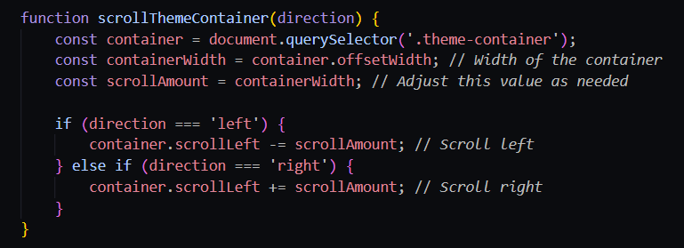
* themes: Lauren and I both worked on making the different color themes this week. I created a settings page that brings up options to toggle between themes. The user can click on the theme they want (ones that they have purchased) and the color scheme changes. This works by reassigning the variables to be different colors through a JavaScript function. I originally made a tedious one, but Lauren created a more useful one that is applied now. The screenshots show the settings page and the Beach Theme applied. 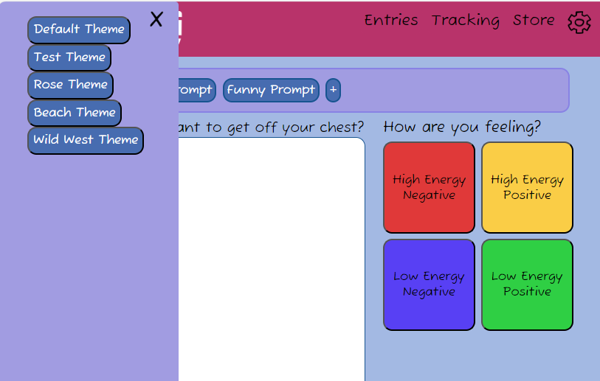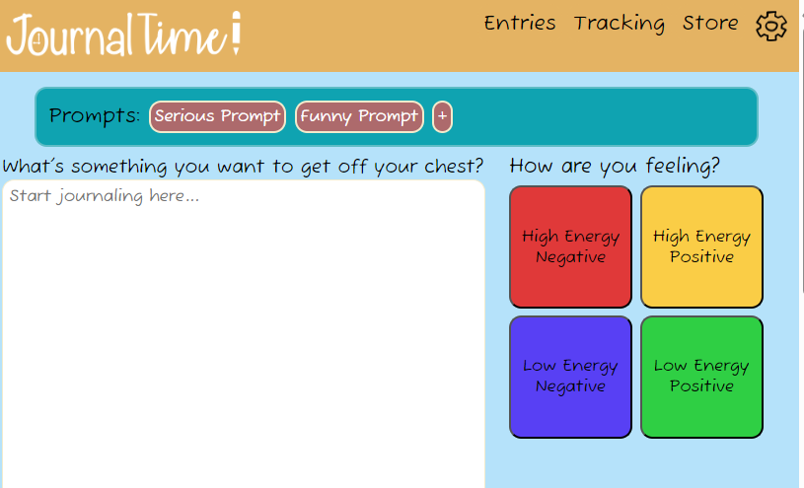

Ava -

# **Difficulties Encountered this Progress Period**

We had some difficulties with Javascript functions that just required going back through and finding errors within the code.

As always, the login page is the worst thing ever. When checking the code with the other pages, it matches exactly, but for some reason it is not showing up.

# **Updated Trello Board and Discussion**

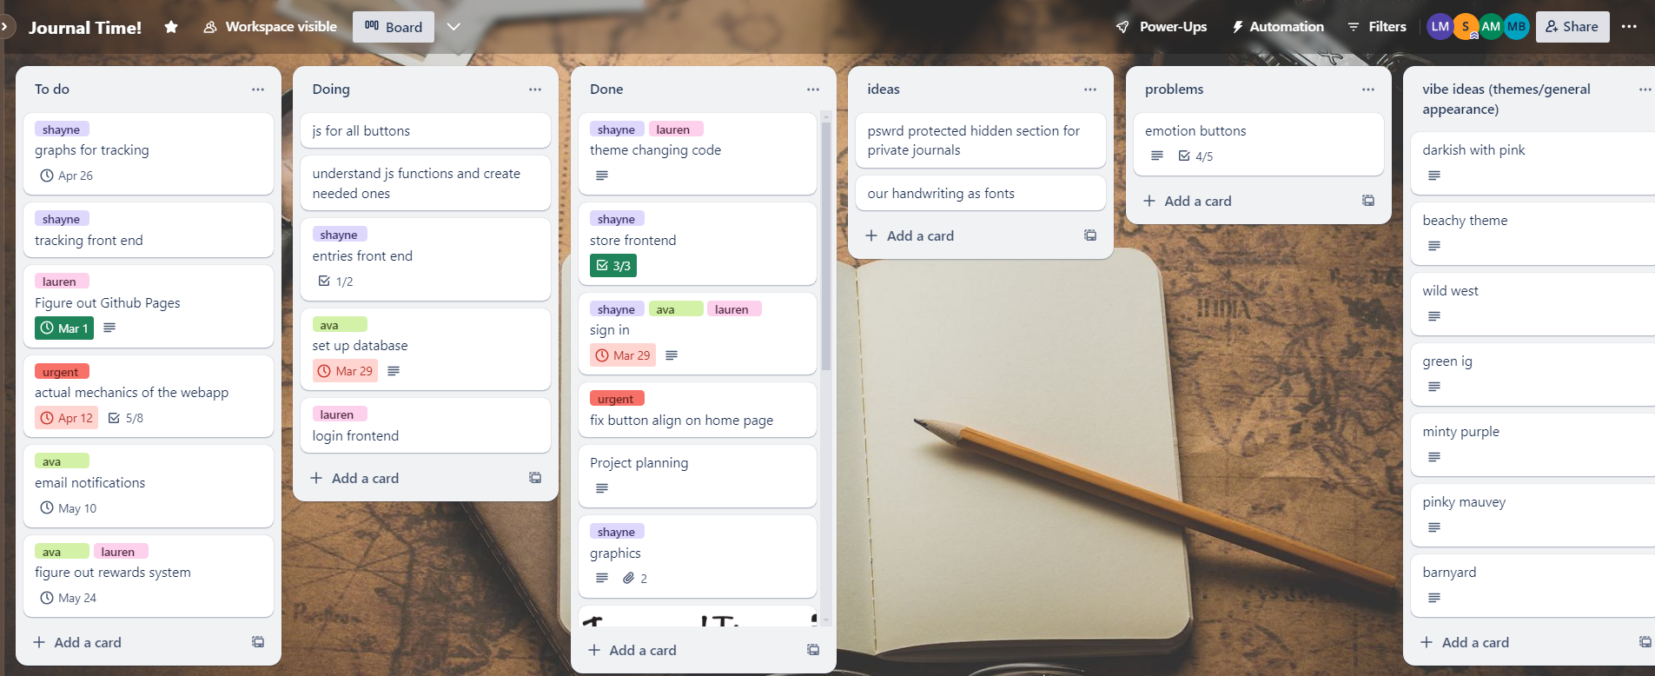

<https://trello.com/b/5P60HsFp>

# **Tasks to Be Worked on in Next Progress Period** **Lauren** -

* connect login page with SQL database
* figure out rewards systems with SQL database/JS
* storing everything in the database (themes, rewards, login info, etc.)
* settings page? possibly

Shayne -

* work towards the functionality of different features on the web app
  + prompt packages
  + themes
  + pets
  + settings
  + being able to actually write and submit entries and emotions

Ava -

* implement more javascript functions into the HTML and CSS
* creating sql database for user information and entries
* connecting database code to the front end

# **Additional Information**

The next step to really move forward is setting up the SQL database. This has been a priority the last few sprints but it still is not set up. We need to all download MySQL so we can get it going instead of leaving it to one person.